Using Slicing
Slicing is used for deleting or removing multiple elements or values

Syntax: del list-name[start:stop:step]

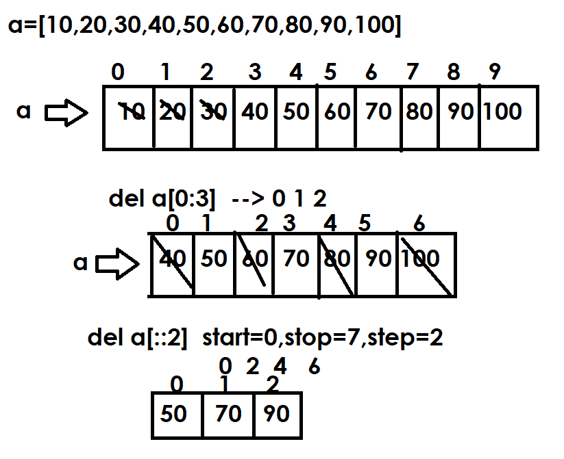
>>> A=[10,20,30,40,50,60,70,80,90,100]
>>> print(A)
[10, 20, 30, 40, 50, 60, 70, 80, 90, 100]
>>> del A[:3]
>>> print(A)
[40, 50, 60, 70, 80, 90, 100]
>>> del A[::2]
>>> print(A)
[50, 70, 90]
>>> del A[::]
>>> print(A)
[]
>>> A=[10,20,30,40,50,60,70,80,90,100]
>>> print(A)
[10, 20, 30, 40, 50, 60, 70, 80, 90, 100]
>>> del A[::-2]
>>> print(A)
[10, 30, 50, 70, 90]

Using remove() method
This method is used to remove to delete value from list using value not using index.

Syntax: list-name.remove(value)

If value exists within list, it removes the first occurrence of value
If value not exists within list, it raises ValueError

>>> A=[10,20,30,40,30,30,50]
>>> print(A)
[10, 20, 30, 40, 30, 30, 50]
>>> A.remove(30)
>>> print(A)
[10, 20, 40, 30, 30, 50]
>>> A.remove(50)
>>> print(A)
[10, 20, 40, 30, 30]
>>> A.remove(50)
Traceback (most recent call last):
File "<pyshell#19>", line 1, in <module>
A.remove(50)
ValueError: list.remove(x): x not in list

Example:
# Write a program to all occurences of given value
# from the given list

A=[10,20,30,10,10,10,40,50,10,30,10,50]
value=10

while True:
if value in A:
A.remove(value)
else:
break

print(A)

Output
[20, 30, 40, 50, 30, 50]

Example:
# Write a program to all occurences of given value
# from the given list

A=[10,20,30,10,10,10,40,50,10,30,10,50]
value=10

while value in A:
A.remove(value)

print(A)

Output
[20, 30, 40, 50, 30, 50]

pop() method
pop() method of list, perform 2 operations
- Return
- Remove
Pop() method by default return and remove last element from list
Pop() is operation belongs to stack data structure (LIFO).
Syntax: variable-name=list-name.pop(index=-1)

Example:
A=[10,20,30,40,50]
print(f"Before Deleting {A}")
value1=A.pop()
print(value1)
print(A)
value2=A.pop()
print(value2)
print(A)
value3=A.pop(0)
print(value3)
print(A)

Output
Before Deleting [10, 20, 30, 40, 50]
50
[10, 20, 30, 40]
40
[10, 20, 30]
10
[20, 30]

Example:
# Write a program to implement stack data structure
# Stack data structure uses LIFO (Last In First Out).
# The element inserted Last is Removed First
# stack allows 2 operations 1.push (add) 2.pop (removing)

stack=[]
while True:
print("1.Push")
print("2.Pop")
print("3.Display")
print("4.Exit")
opt=int(input("Enter Your Option:"))
if opt==1:
ele=int(input("Enter Element to Push:"))
stack.append(ele)
print("Element pushed inside stack")
elif opt==2:
if len(stack)==0:
print("Stack is empty")
else:
ele=stack.pop()
print(f'{ele} is removed from stack')
elif opt==3:
print(stack)
elif opt==4:
break
else:
print("invalid option")

Output
1.Push
2.Pop
3.Display
4.Exit
Enter Your Option:1
Enter Element to Push:10
Element pushed inside stack

clear() method
This method is used for removing or deleting all the elements from list (OR) empty list

>>> A=list(range(10,110,10))
>>> print(A)
[10, 20, 30, 40, 50, 60, 70, 80, 90, 100]
>>> A.clear()
>>> print(A)
[]
>>> A=list(range(10,110,10))
>>> print(A)
[10, 20, 30, 40, 50, 60, 70, 80, 90, 100]
>>> del A[::]
>>> print(A)
[]

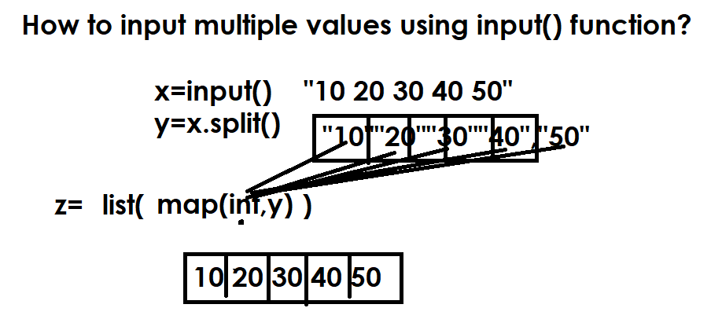

https://www.hackerrank.com/challenges/find-second-maximum-number-in-a-list/problem?isFullScreen=false

n=int(input())
A=list(map(int,input().split()))
A.sort()
B=[]
for value in A:
if value not in B:
B.append(value)

print(B[-2])

inserting elements within list

Adding element in between elements list is called insertion.
Inserting element within list is done using,
- Insert() method
- Slicing

insert() method
This method of list is used for inserting single element or value at the given index/position.

Syntax: list-name.insert(index,element)

If the index is not within range, it inserts value/element at beginning or ending.

>>> A=[10,20,30,40,50]
>>> print(A)
[10, 20, 30, 40, 50]
>>> A.insert(2,60)
>>> print(A)
[10, 20, 60, 30, 40, 50]
>>> A.insert(4,100)
>>> print(A)
[10, 20, 60, 30, 100, 40, 50]
A.insert(10,99)
print(A)
[10, 20, 60, 30, 100, 40, 50, 99]
A.insert(-5,66)
>>> print(A)
[10, 20, 60, 66, 30, 100, 40, 50, 99]
>>> A.insert(-15,500)
>>> print(A)
[500, 10, 20, 60, 66, 30, 100, 40, 50, 99]
>>> A.insert(1,11,22,33)
Traceback (most recent call last):
File "<pyshell#40>", line 1, in <module>
A.insert(1,11,22,33)
TypeError: insert expected 2 arguments, got 4

Inserting multiple elements are done using slicing

